K-ON! — The Borrowed Stage
Description | As a kid, I remember watching this episode that aired on April 14th, 2010 and wanting to go to this EXACT spot and recreate this pose, but 2D animation is not real :( - HOWEVER, as I got older, I found out that the guitarist is a real person??!! Which means this spot is real and this stage is real! I'd like to visit the place captured in the photograph he resembles. What was the concert site called?
Files | pause.jpg — one official-anime frame. Submit the specific concert-site name as RCC{site_name}.  K-ON!!, season 2, episode 2, “Clean-up!” © Kakifly / Houbunsha / Sakuragaoka High School Light Music Club.
Hint(s) | 1. The guitar appraisal briefly borrows the visual language of real rock musicians. Concentrate on the last guitarist's clothing and pose.  2. The illustrated guitarist resembles Pete Townshend. Find a photograph matching the whole pose, rather than any picture of him with an SG.  3. A Who equipment archive dates a matching crop to the 1969 Isle of Wight festival. Its different editions used different sites.
Walkthrough | 1. Search for the real musicians represented in Sawako's guitar-appraisal montage. The Los Endos scene analysis pairs the supplied frame with Pete Townshend, photographed by Barrie Wentzell. Compare the raised arm, white clothes, guitar and leg position.  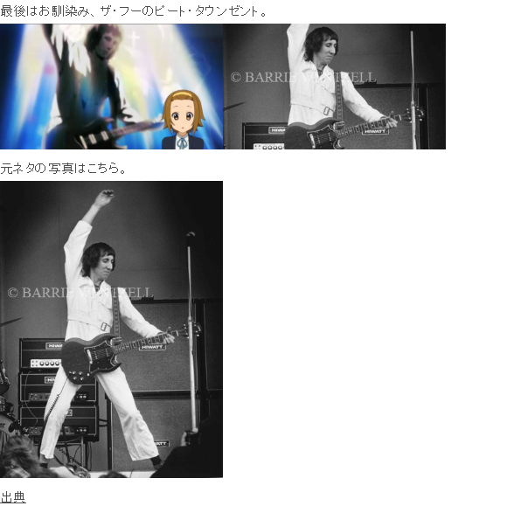  2. Follow Townshend's stage equipment to Whotabs' Sound City / Hiwatt article. Match its photograph crop using the guitar, coiled lead, amplifier stack and foreground spectator. The caption identifies the August 1969 second Isle of Wight festival.  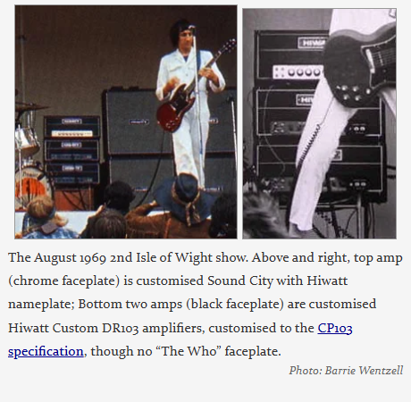  3. Find the site used for that festival edition. Wootton Bridge's festival history places the 1969 event at Woodside Bay and includes The Who in its lineup. Bob Dylan's official concert archive independently names Woodside Bay for the same festival.    4. Submit Woodside Bay. The island name is too broad; Ford Farm and Afton Down belong to other festival editions.
Flag | RCC{woodside_bay}

